Name: Ziad alaa elshenawy Group: SWE 1
Task 1:
Item | Your finding
Current branch | main
Number of visible branches | 3
Names of feature branches | feature-search, feature-stock-validation
Latest commit message on main | Add project changelog

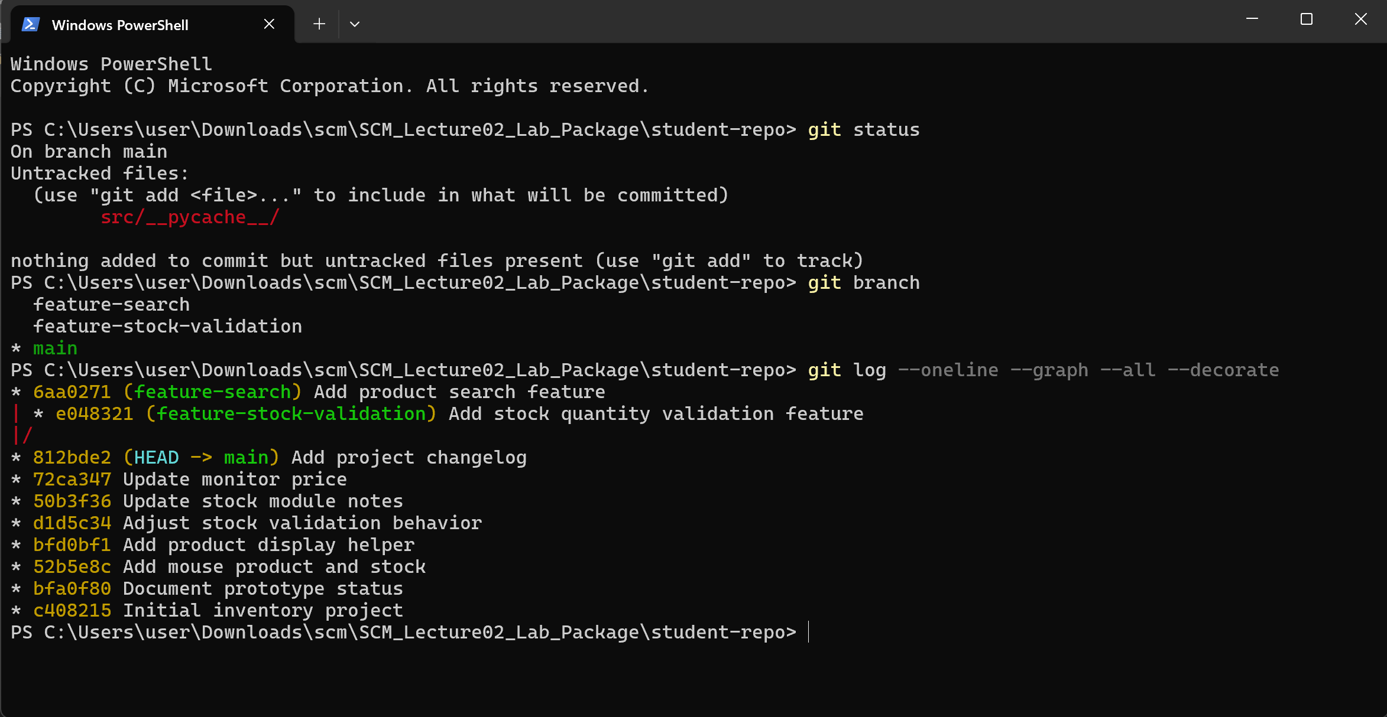
1. What is the main difference between a centralized VCS and a distributed VCS?
Answer: In a Centralized Version Control System (CVCS), a single central server holds the master repository and full version history; developers connect to this central node to pull working copies and push changes. In contrast, a Distributed Version Control System (DVCS) like Git provides every developer with a full, independent clone of the complete repository, including its entire historical commit graph and branches.
2. Why is a distributed VCS less dependent on one central repository for local work?
Answer: Because each local clone possesses the entire database and history locally, developers can perform virtually all essential operations—such as creating commits, branching, switching context, reviewing history, and diffing code versions—completely offline and without network access or dependence on a single remote server.
3. What is the purpose of creating a feature branch?
Answer: A feature branch isolates new functionality, bug fixes, or experimental work away from the stable production branch (main). This allows concurrent development among multiple team members without destabilizing the main codebase until code review and testing are completed.
Task 2:
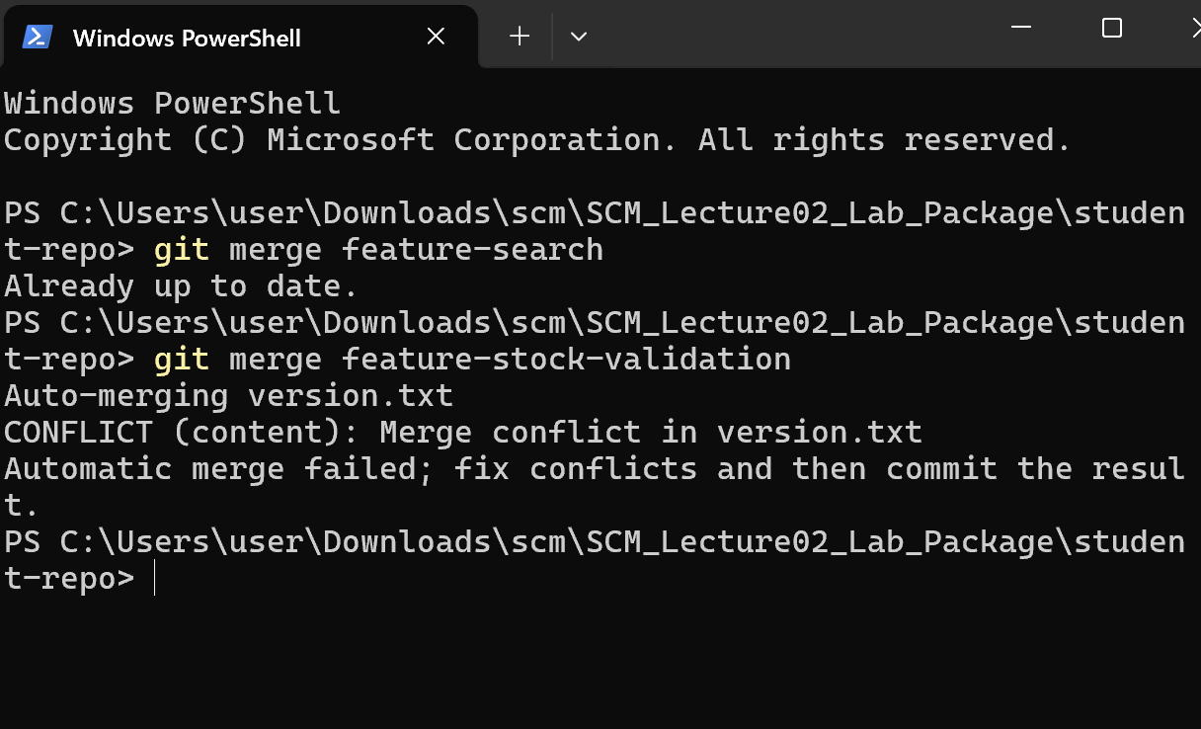
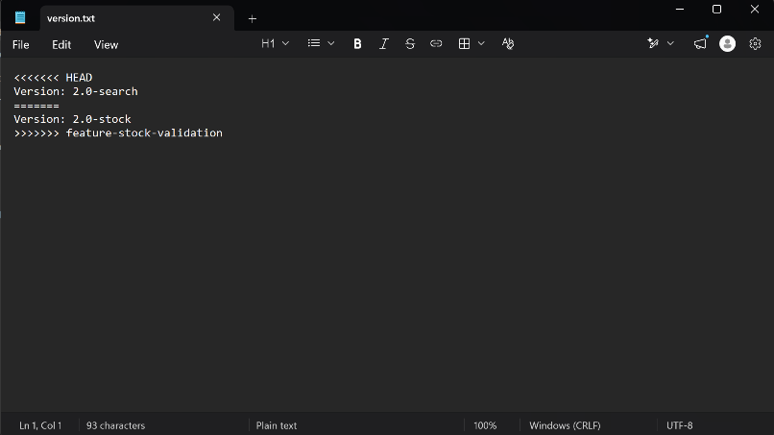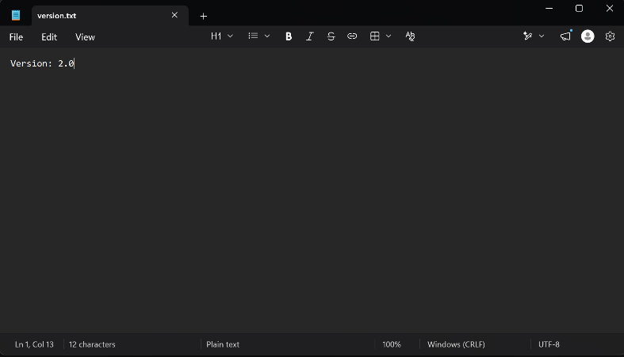
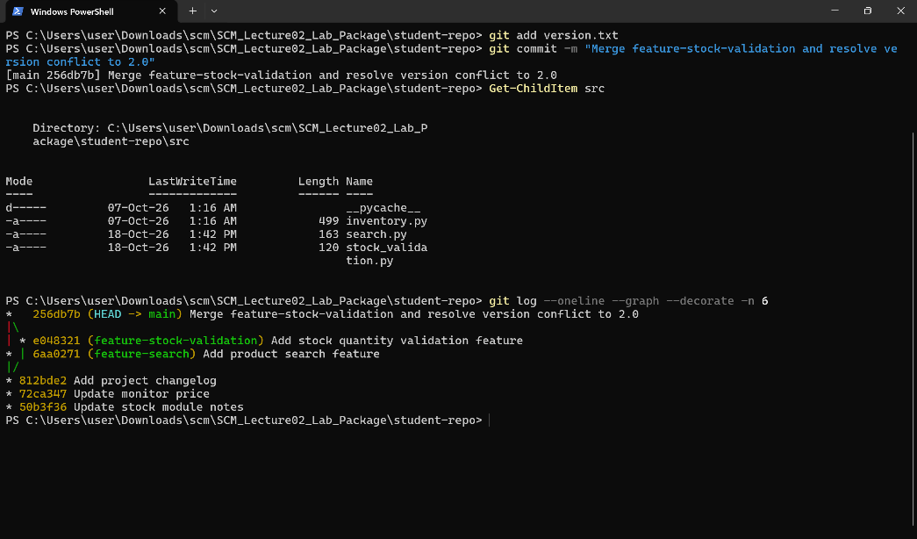
Why could Git not automatically choose between the two version numbers?
Both 'feature-search' and 'feature-stock-validation' diverged from the exact same base commit on main, and both branches modified the exact same line within 'version.txt' independently. Because both commits introduced conflicting edits to the exact same location since their common ancestor, Git has no deterministic, semantic way to decide which version takes precedence, intentionally halting to require human resolution.
Task 3:
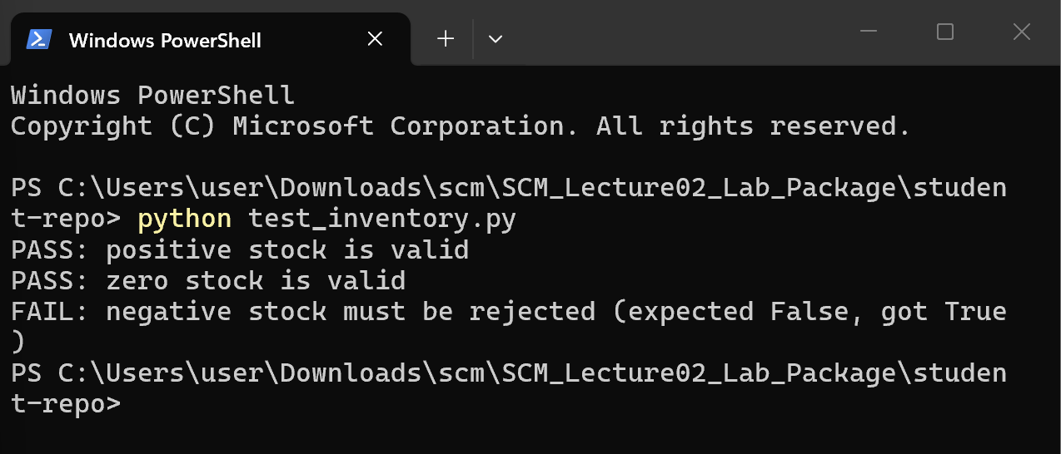
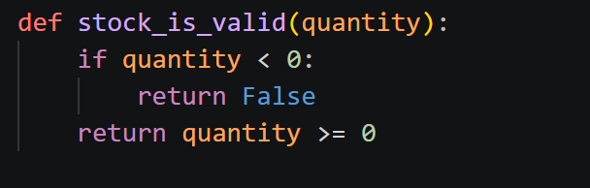
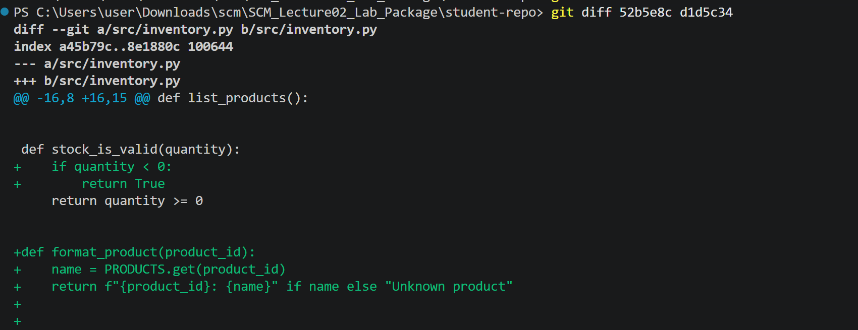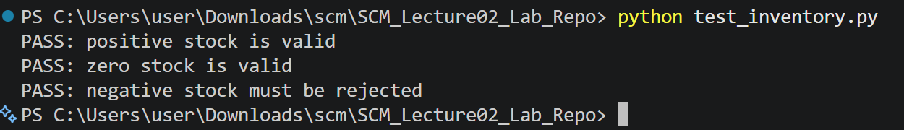
Investigation item | Your answer
Failing file/function | src/inventory.py / stock_is_valid
Commit hash that introduced the defect | d1d5c34
Commit message | Adjust stock validation behavior
Incorrect behavior | When quantity < 0, it returns True, thereby validating and accepting negative stock
Correct behavior | When quantity < 0, it must reject negative stock (return False); it should only return True for zero or positive values (quantity >= 0)

Task 4:
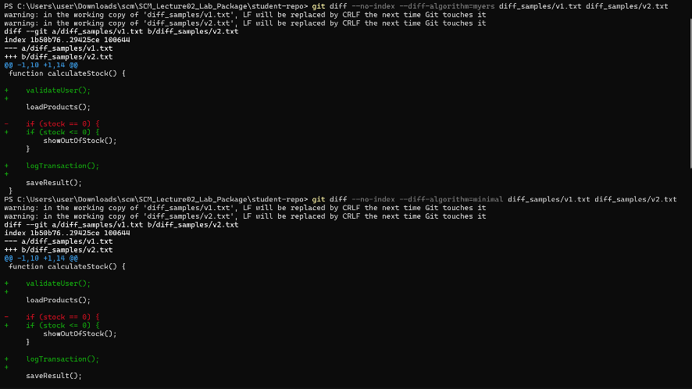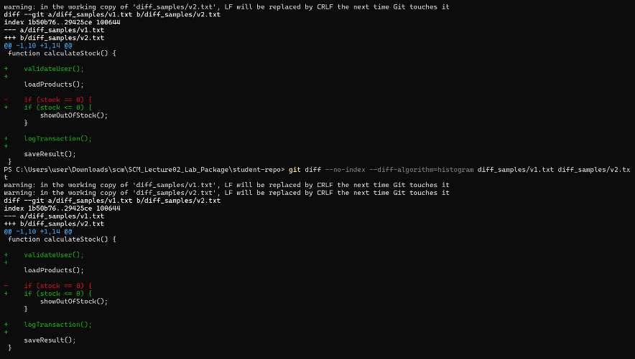
Algorithm | Easy to read? | Main observation | Ranking (1-4)
Myers | Moderate | Default greedy algorithm; finds the shortest edit script but can split semantic blocks or matching brackets awkwardly across hunk boundaries. | 3
Minimal | Moderate | Spends additional computation to find strictly minimal line differences; output is often virtually identical to Myers for small sample files. | 4
Patience | Yes | Matches unique common lines first (like function signatures); avoids matching isolated brackets, producing clean, logically grouped hunks. | 1
Histogram | Yes | An optimized, high-performance variant of patience; handles repetitive and low-occurrence lines cleanly, keeping functions readable. | 1

Which diff output was easiest for you to understand, and why?
The Patience diff output was the easiest to understand because it preserves the syntactic structure of the code. While standard algorithms like Myers focus strictly on finding the shortest mathematical edit script, they frequently match repetitive lines—such as blank spaces or closing brackets—to unrelated sections, fragmenting the changes. In contrast, Patience anchors its comparisons around unique lines like function headers, keeping complete blocks intact. This semantic alignment prevents confusing hunks and clearly reflects the developer's actual intent.

Task 5:
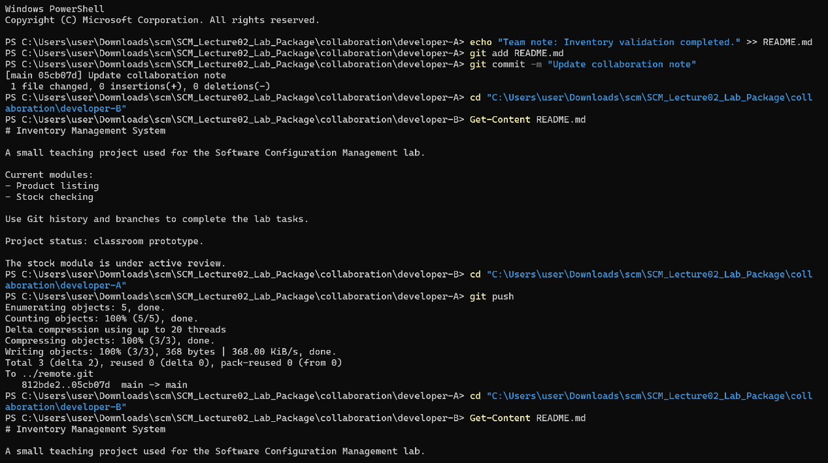
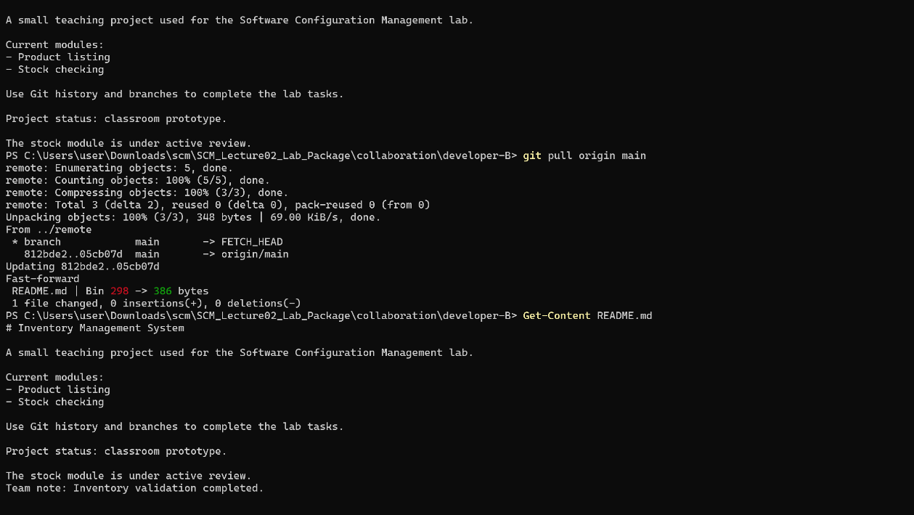
Stage | Stored in A locally? | On remote? | Visible in B?
After edit | Working Tree only (untracked / modified) | No | No
After commit | Yes (Committed in local .git repo) | No | No
After push | Yes (Local repo updated) | Yes | No
After pull in B | Yes | Yes | Yes
Why does git commit alone not make Developer A's change visible to Developer B?
Because Git is a distributed version control system, meaning each developer works with their own independent copy of the repository. For Developer B to see the changes:
Developer A must push: Run git push to upload the committed changes to a shared central repository (like GitHub or GitLab).
Developer B must pull: Run git pull to download those changes from the shared repository to their own machine.

Task 6:
Question 1: Commit Hash Behavior
Short Hash of Latest Commit: To view the short hash of your most recent commit, run: (git log -1 –oneline)(004553a).Hash Comparison After a New Commit: The new commit will have a different hash. In Git, a commit Because hash is a cryptographic checksum generated from the exact tree (file snapshots), commit metadata (author, committer, timestamp, commit message), and crucially, the hash of its parent commit(s). Because each commit introduces new timestamps and points to the previous commit as its parent, the resulting hash is uniquely distinct.
Qusestion 2:
A single hexadecimal digit represents 16 possible values (0-9 and a-f), which corresponds to 4 bits of binary information (2^4 = 16). Dividing the total number of bits by the number of bits represented by each hexadecimal character yields exactly 40 characters: 160 bits / 4 bits per digit = 40 hexadecimal digits
Qusestion 3:
Hashing in Git guarantees data integrity by making history tamper-evident and enables fast, deduplicated storage by identifying objects directly by their content.
Qusestion 4:
The public key is the only key that may be safely shared with and uploaded to remote hosting services
Qusestion 5:
The private SSH key must be kept secret because it serves as the sole cryptographic proof of your identity in asymmetric authentication

Task 7:
Final Report and Verification:
Version control systems serve as the core governance layer in modern software delivery. By isolating workstreams through Git’s branching architecture, organizations enable parallel development velocity while protecting production stability. Git’s distributed design safeguards business continuity, giving every engineer complete, offline access to repository history. Cryptographic verification—via SHA content addressing and SSH-based authentication—guarantees end-to-end provenance and tamper resistance across all artifacts. Ultimately, Git delivers the auditability, security, and resilience necessary for high-trust continuous integration and compliant deployment.

